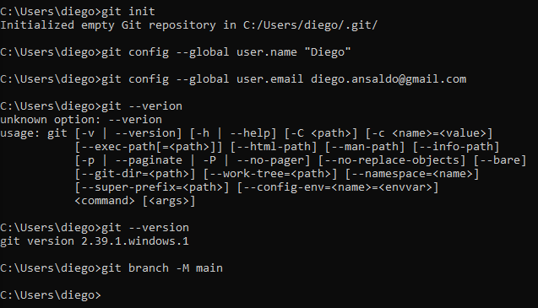

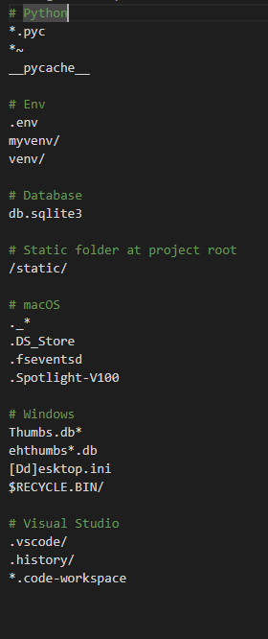

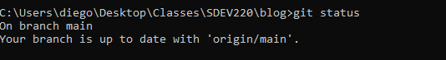

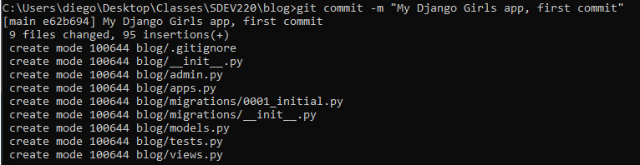

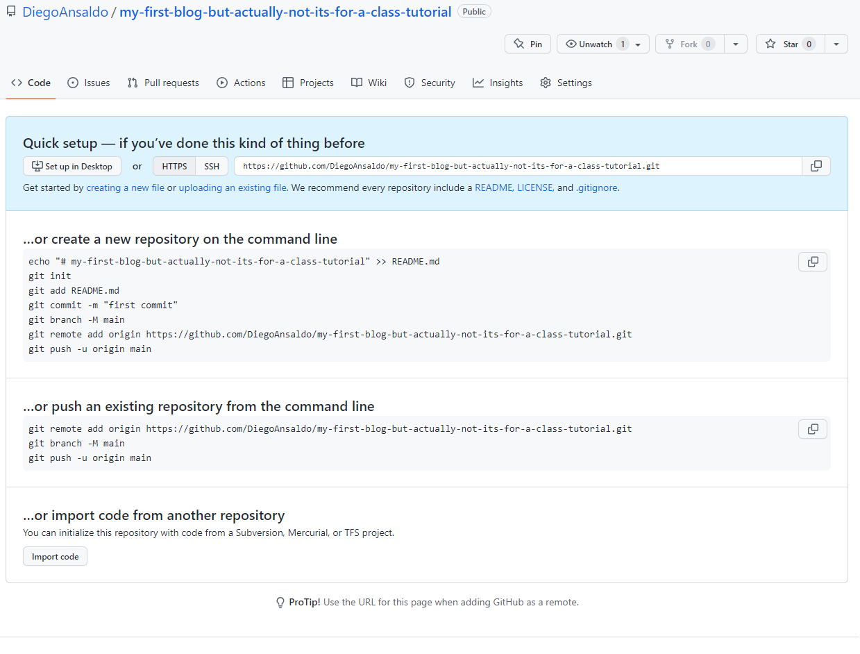

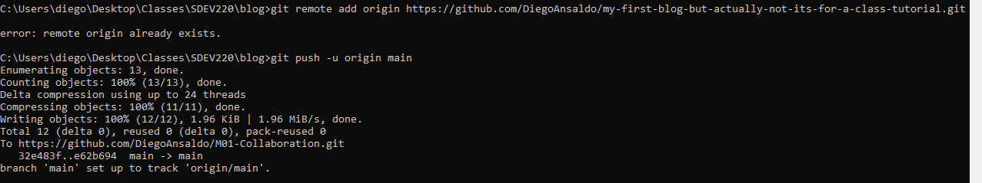

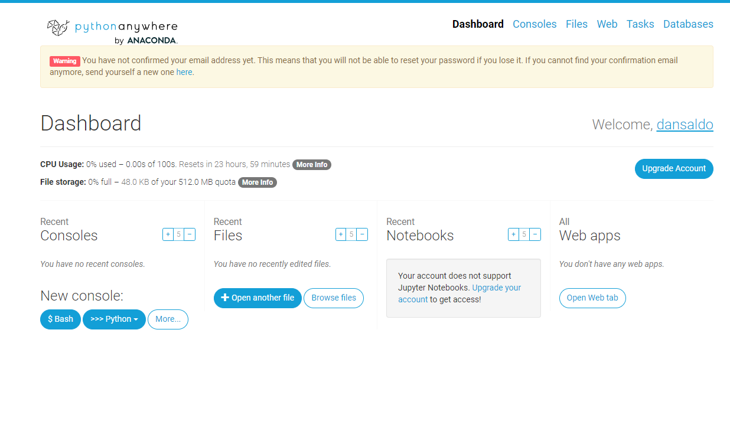

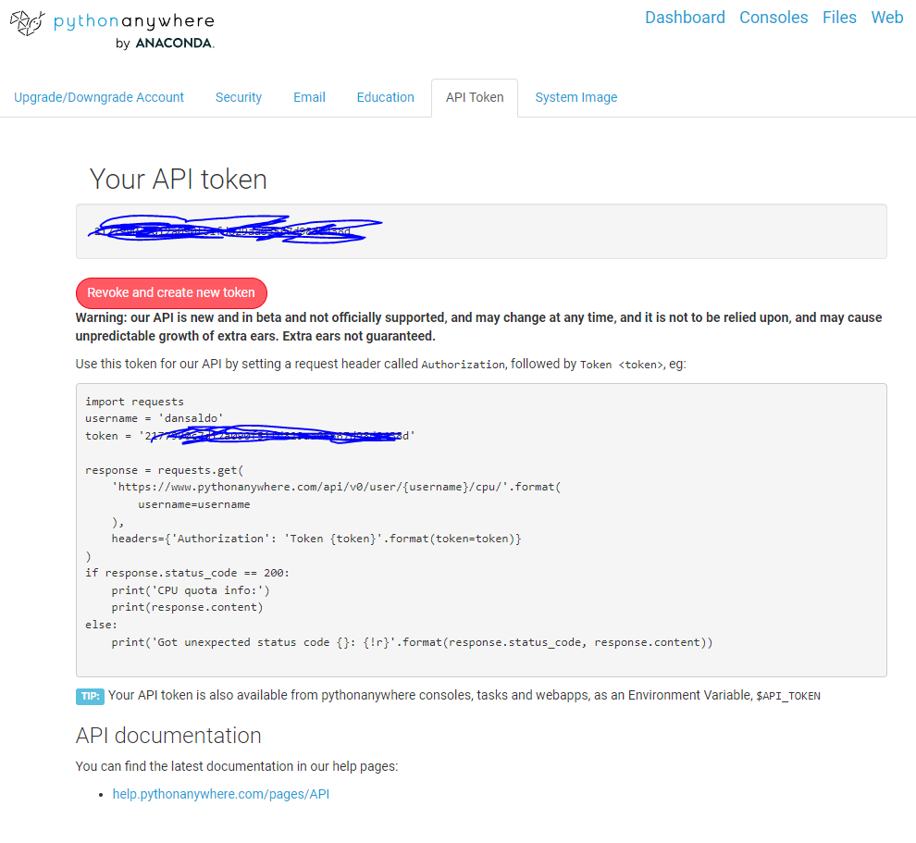

(I covered up the actual token because I was unsure about the security)

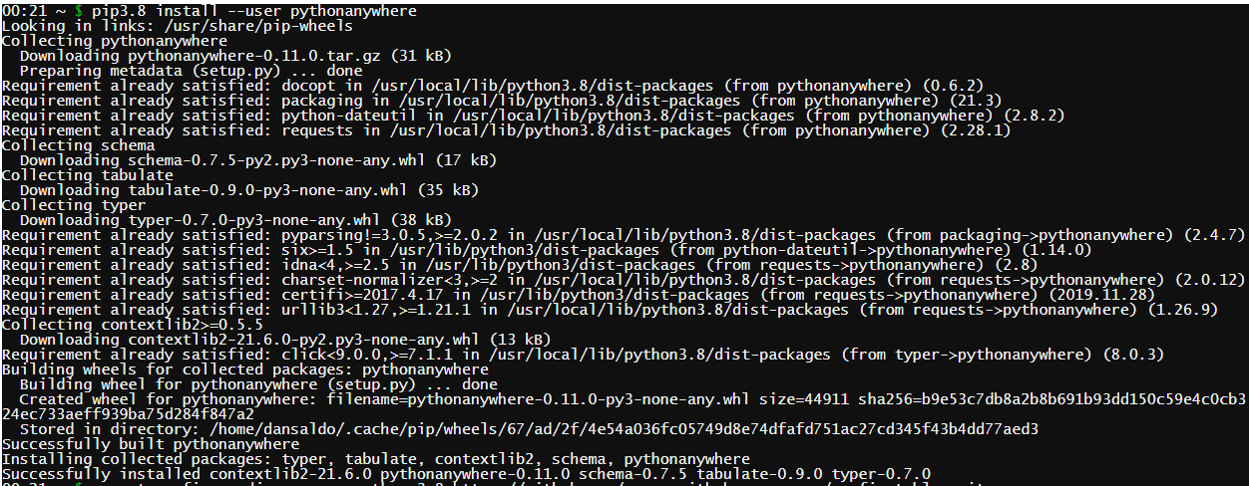

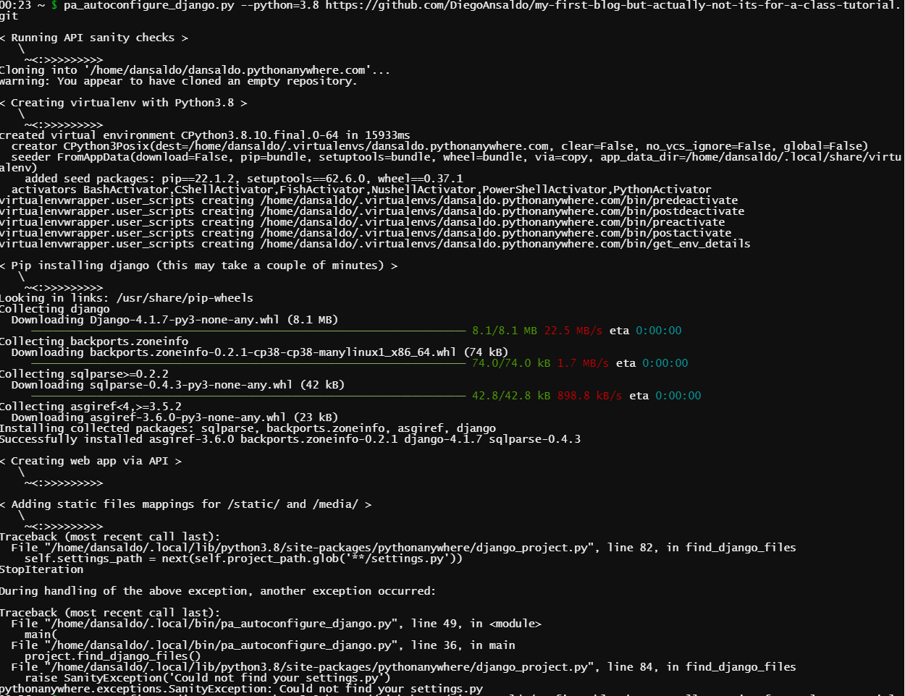

(So right around here I ran into issues as you can see. The program could not find some of my settings files, and I have no idea why. Because the tutorial was broken up through multiple weeks in different assignments, I have no idea if I did something wrong back then, or now, or what. Honestly I would love to know what happened, but I have no idea, and I could not find a fix. I tried moving on with the assignment, but I think it would be pointless without fixing this. I was unable due to my schedule to work on this assignment early enough to have time to find a fix, but I will make time to start my assignments earlier so this does not happen again. I do not enjoy submitting assignments like this, but on this occasion I have no other option. I appologise, and I will do my absolute best to do better.)